**Library Management System Manual**

Software: JAVA, NETBEANS IDE 8.2, MS ACCESS

The basic steps of using this database application are as follows:

1. Download the library management system.zip and extract its content.
2. Get a NetBeans Java IDE. Install and open Net Beans IDE.
3. Click open project and next on java, and browse and select the project name as Library Management System.
4. Once the folder is created in left side, select the project and click new folder and name it as library.
5. In this folder paste the UcanAccess Jar files. These files are given in new folder.
6. From the folder get the MS access JLibrary.mdb database file. Store this file in E drive.
7. Open, odbc driver datasource engine. In this select Add and write database name as JLibrary.
8. Browse and select the path of the JLibrary as E:/ JLibrary.mdb. And then Click Okay. This shall create the ODBC connection with the MSACCESS database.
9. Now open the project main file. Incase your JLibrary.mdb is in different folder than E, then change the path : connection= DriverManager.getConnection(" jdbc:ucanaccess://E:\\JLibrary.mdb"); to the destination folder in each source code java file. For example change this path in line 58 of Borrow.java
10. Once the connection is set, Run Main.java and does the library transaction.

The database and its tables are:

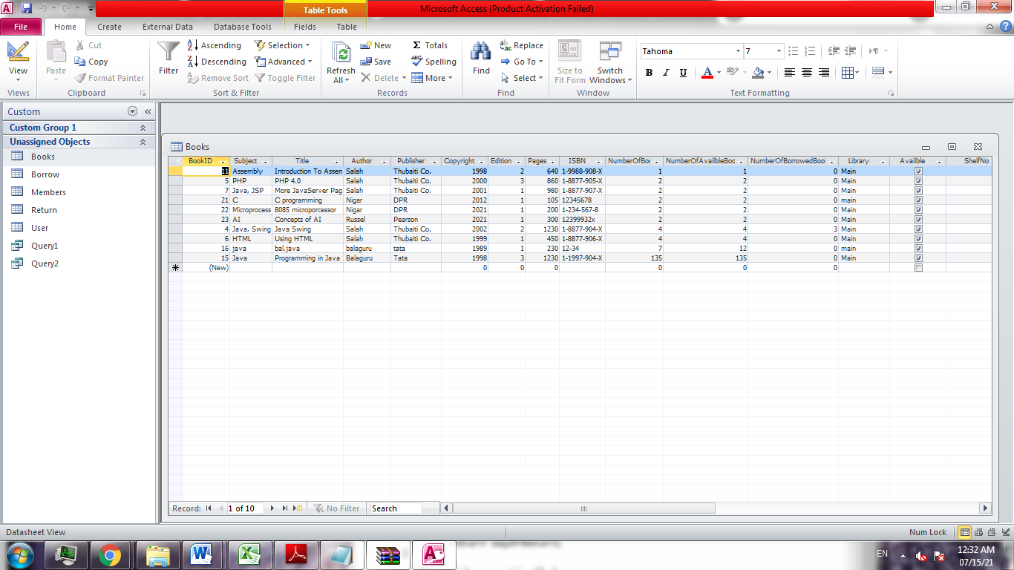

Program execution

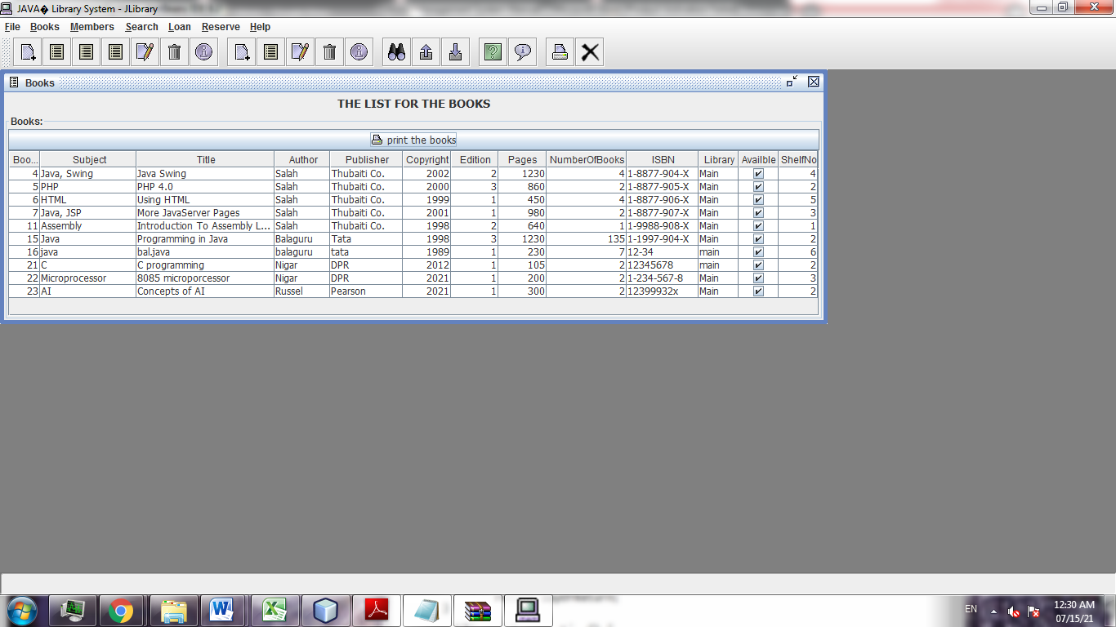

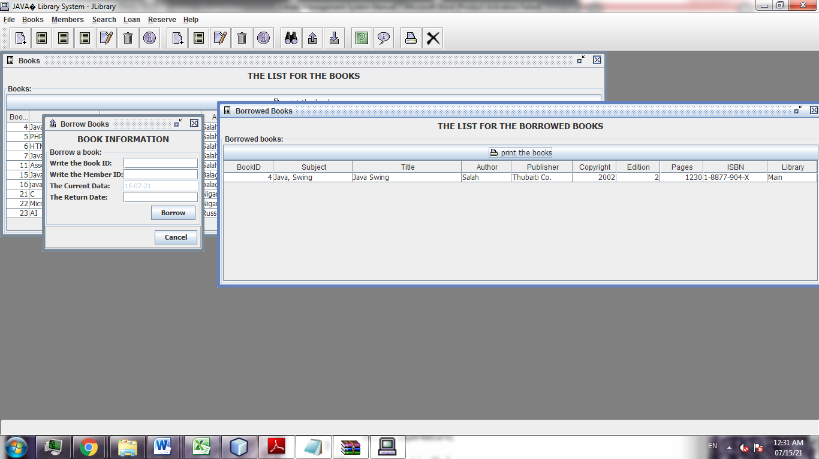

# ER DIAGRAM

